Organic chemistry II

Question Paper 1

|  |  |
| --- | --- |
| School | Miritini Secondary School |
| Student’s Name |  |
| Level | KCSE |
| Subject | Chemistry |
| Topic | Organic chemistry II |

**Time allowed:** 1Hour 20 min

**Marks scored: ______ / 60**

1. (a) Write down the formula for ethanol and draw its structural formula. [1]

(b) Ethanol is produced by fermentation of sugar solutions.

1. Name the other product of fermentation. [1]

______________________________________________________________

1. Give two other condition which are necessary before fermentation takes place. [2]

________________________________________________________________________________________________________________________________

1. How can dilute solution of ethanol produced by fermentation be concentrated? [1]

________________________________________________________________________________________________________________________________________________________________________________________________

1. State two uses of ethanol. [2]

________________________________________________________________________________________________________________________________________________________________________________________________________________________________________________________________

1. Write the structural formula of each of the following substances.
2. C3H7OH [1]
3. CH3COOH [1]
4. Butanoic acid [1]
5. Hexan-1-ol [1]
6. The boiling point of the first six alkanols are given in the following table.

|  |  |  |  |  |  |  |
| --- | --- | --- | --- | --- | --- | --- |
| Number of carbon atoms | 1 | 2 | 3 | 4 | 5 | 6 |
| Boiling points (0C) | 64 | 78 | 97 | 117 | 132 | 154 |

1. What conclusion can be drawn from the information given in the table above? [1]

______________________________________________________________________________________________________________________________________________________________________________________________________

1. The boiling points of the **first six alkanes** are much lower compared to those of alkanols of same number of carbon atoms given in the table above. Explain. [1]

________________________________________________________________________________________________________________________________________________________________________________________________________________________________________________________________________

1. Two alkanols X and Y have the same composition by mass: carbon 60%, hydrogen 13.3% and the rest is oxygen. Their relative molecular mass is 60.
2. Determine the empirical formula and the molecular formula of compound **X** and **Y**. [3]

________________________________________________________________________________________________________________________________________________________________________________________________________________________________________________________________________________________________________________________________________________________________________________________________________________________________________________________________

1. Write the structural formula for the two isomers. [4]
2. Name the two isomers. [2]

________________________________________________________________________________________________________________________________________________________________________________________________

1. (a) Which organic acid and alkanols could be used to make
2. Ethyl methanoate

Acid _________________________________________________________ [½]

Alkanol _______________________________________________________ [½]

1. Methyl butanoate.

Acid _________________________________________________________ [½] Alkanol _______________________________________________________ [½]

1. What is the general name for substances named (i) and (ii) above? [1]

____________________________________________________________

1. Write the chemical equations for (a) (i) and (ii) above to show how they are formed. [4]

___________________________________________________________________________________________________________________________________________________________________________________________________________________________________________________________________________________________________________________________

1. The following scheme represents the manufacture of a cleaning agent Y.

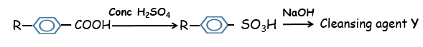

1. Draw the structure of **Y** and state the type of cleaning agent to which **Y** belongs.

Structure [1]

Type of cleaning agent [1]

_____________________________________________________________

1. State one disadvantage and one advantage of using Y as a cleansing agent. [2]

________________________________________________________________________________________________________________________________________________________________________________________________________________________________________________________________________________________________________________________________________________________________________________________________

1. The following formula represents a portion of a polymer.

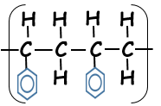

1. What is the name of the polymer? [1]

_______________________________________________________________

1. Give one disadvantage of continued use of the polymer. [1]

________________________________________________________________________________________________________________________________________________________________________________________________

1. Give the names of the following compounds.
2. CH3CH2CH2CH2CH2OH [1]

________________________________________________________________

1. CH3CH2CH2CH2COOH [1]

________________________________________________________________

1. CH3CH2CH2CH2OOCCH3 [1]

________________________________________________________________

1. During the manufacture of tyre, raw rubber is heated with Sulphur, carbon, phosphorus and manganese.
2. What name is given to this process? [1]

________________________________________________________________

1. Explain why the process is necessary. [1]

________________________________________________________________________________________________________________________________

1. In an experiment, a student placed a small sample of methanoic acid in a beaker. A small amount of sodium carbonate was added to the acid.
2. State what was observed when sodium carbonate was added to the acid. [1]

______________________________________________________________________________________________________________________________________

1. Write an equation for the reaction. [1]

______________________________________________________________________________________________________________________________________

1. A section of this polymer has the following structure;

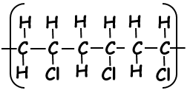

A sample of this polymer is found to have a **molecular mass of 70**.

1. Identify the monomer and draw its structure. [1]
2. Determine the relative molecular mass of the monomer. [1]

_________________________________________________________________________________________________________________________________________________________________________________________________________

1. Determine the number of monomers in the sample. [1]

___________________________________________________________________

1. There is a similarity between the reaction of ethanol with sodium metal, and the reaction of water with sodium.
2. What is this similarity? [1]

______________________________________________________________________________________________________________________________________

1. Write chemical equations to show the similarity. [2]

____________________________________________________________________________________________________________________________________________________________________________________________________________________________________________________________________________

1. The diagram below shows the set-up for the laboratory preparation of soap. Study it and then answer the questions that follow.

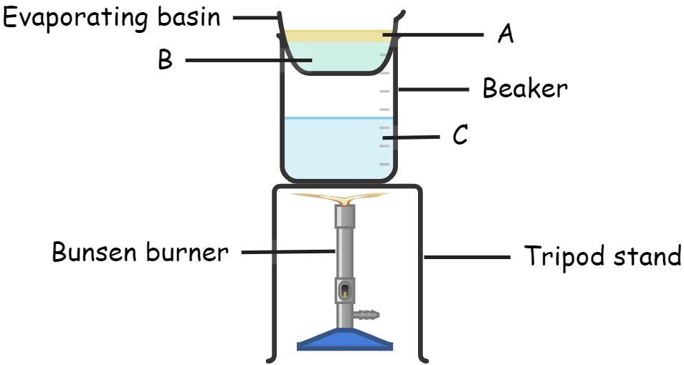

1. Identify substance **A**, **B** and **C**.

A ___________________________________________ [1]

B ___________________________________________ [1]

C ___________________________________________ [1]

1. A saturated solution of sodium chloride is finally added to the product in the evaporating basin. Explain the purpose of this. [1]

________________________________________________________________________________________________________________________________________________________________________________________________

1. What is name given to the whole process of preparing soap? [1]

________________________________________________________________

1. There is hydrogen bonding between molecules of ethanol. Explain why:
2. Hydrogen bonding is possible. [1]

______________________________________________________________________________________________________________________________________

1. Ethanol dissolves in water. [1]

______________________________________________________________________________________________________________________________________

1. The boiling point of ethanol is higher than that of ethane. [1]

_________________________________________________________________________________________________________________________________________________________________________________________________________

1. Draw the structure of the polymer formed from the following monomers: [4]
2. 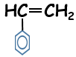
3.  and 